F-03 - F-03 - GL Manual Account Clearing

Functionality
This function allows you to clear open items on the GL account. It differs from posting with a clearing transaction or posting with a payment in the following ways:
- You do not need to enter a document header
- You can only clear open items from one account

Scenario

There are some postings on GL account that are not cleared. You want to clear these postings.

Prerequisites
Open items on GL account.

Menu Path | Accounting → Financial Accounting → General Ledger → Account → F-03 - Clear
Transaction Code | F-03

1. Double click on F-03 – Clear.

Clear G/L Account: Header Data

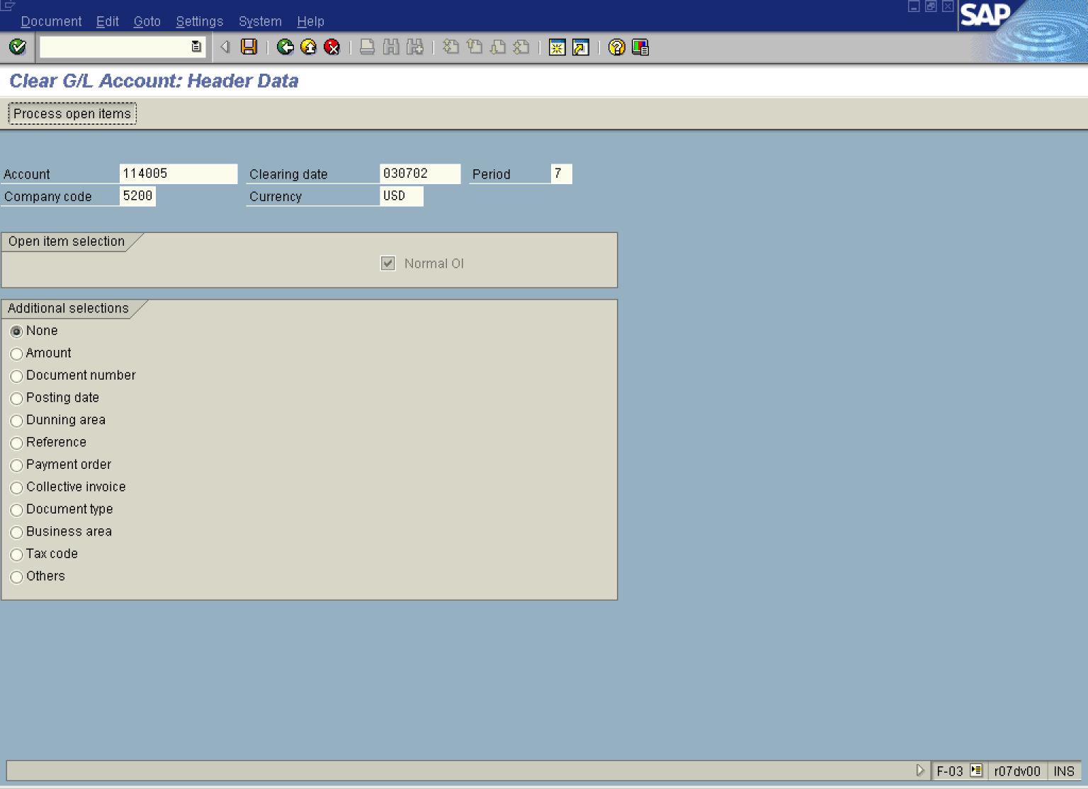

2. Update the following fields:

Field Name | Field Description | Values
Account | Code identifying the General Ledger account | Example: 114005
Clearing date | Date when you want to post your clearing | Example: 030702
Company code | Code identifying a separate legal entity for which a separate set of accounts is maintained for external reporting purposes | Example: 5200
Currency | Code identifying the type of currency used in a transaction or for all transactions pertaining to a specific account | Example: USD

Tip: You can clear also the transactions posted in different currencies. The system will automatically calculate and post exchange rate differences.

3. Click Process open items Button . The system will display open items that fulfill previously entered criteria:

Clear G/L Account: Process open items

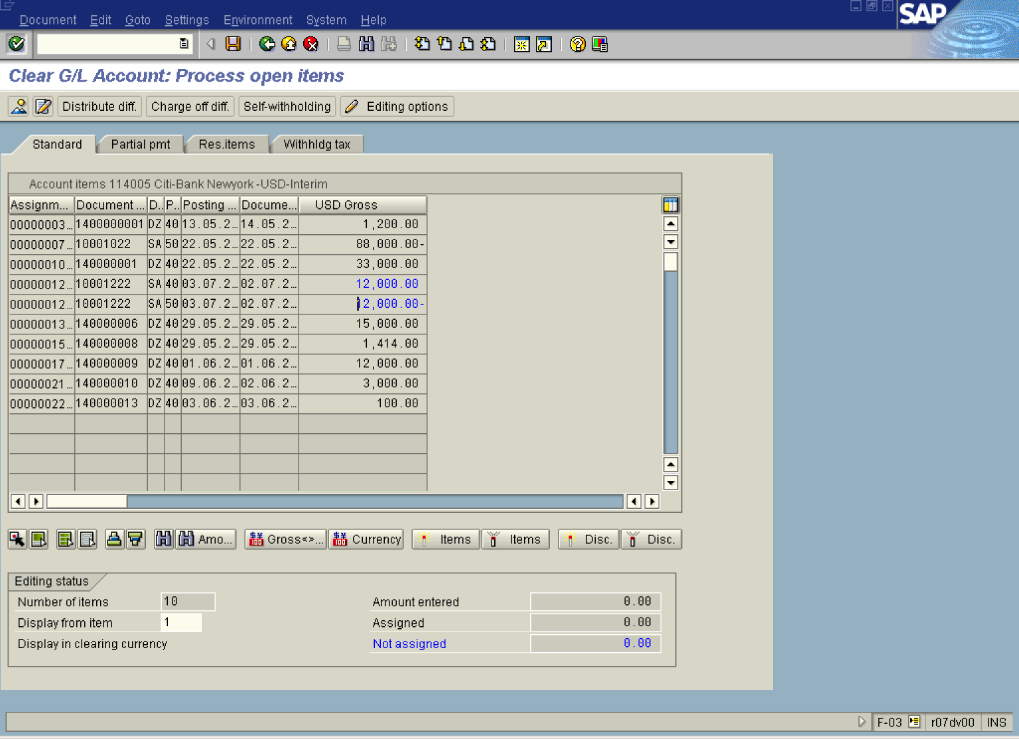

4. Now you need to choose and select the items you want to clear. Double click on each of those items. E.g. choose documents 10001222 and 140000009. The system will highlight these items in blue. The value of the field “Not assigned” is equal 0 and you can clear open items. If it is not zero, you the difference in the amount must be treated as partial or residual items.

5. You can check your document before postings. Select DocumentSimulate.

Clear G/L Account: Display Overview

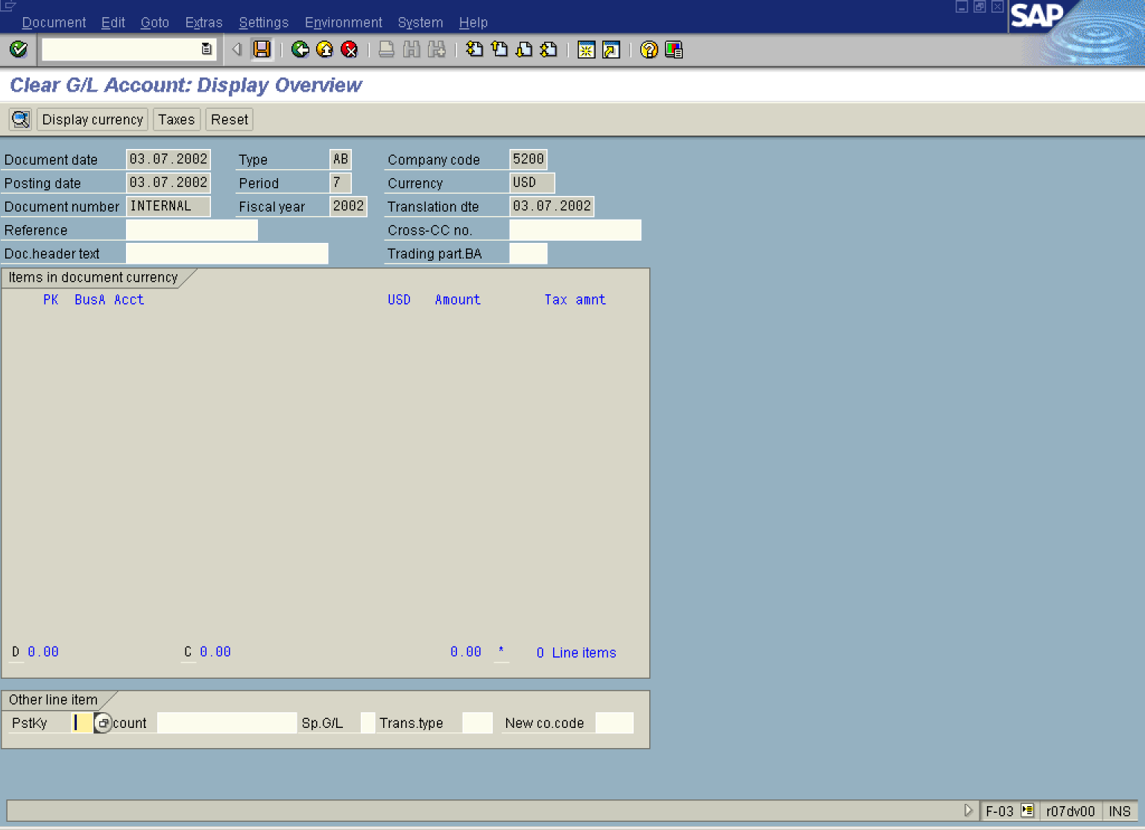

. To post your entries, click Save Button.. No “real” posting took place, but the system stored a clearing document.

6. The message bar displays: “Document XXXXXX as posted in company code 5200”.

Tip: If you want all your open items NOT TO BE SELECTED when you enter the clearing transaction, perform the following steps:

Clear Vendor: Header Data

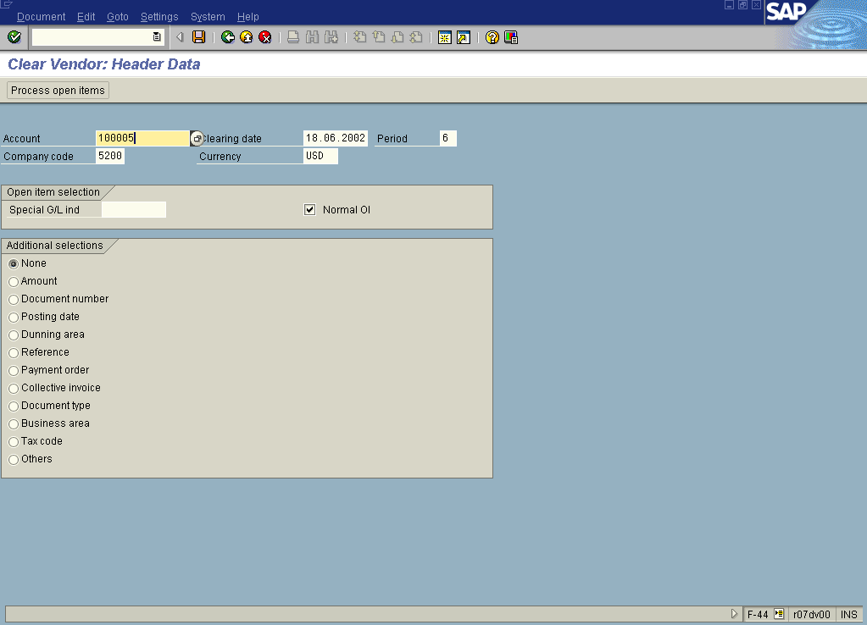

7. On the screen above use the following menu path: SettingsEditing options.

Accounting Editing Options

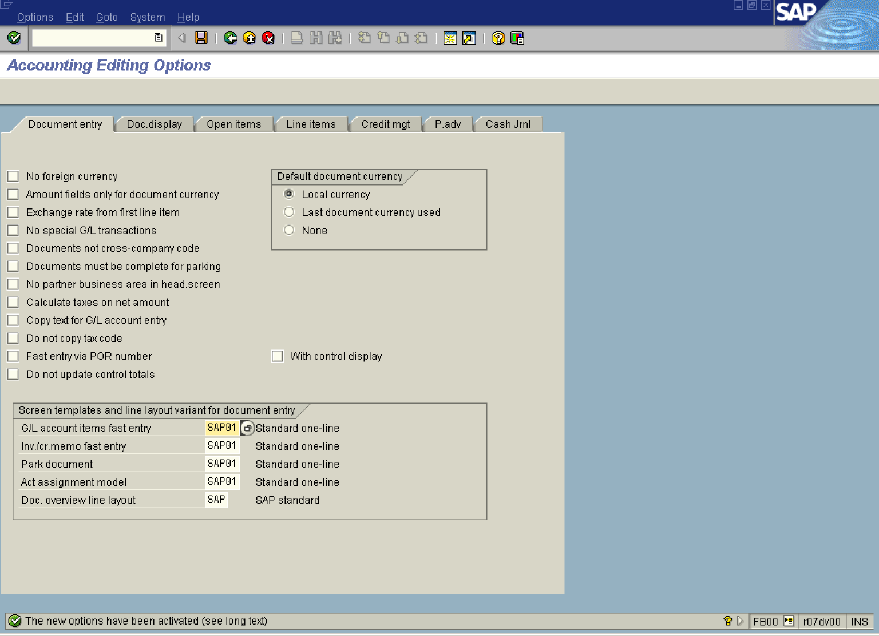

8. Click <tab button> Open items .

Accounting Editing Options

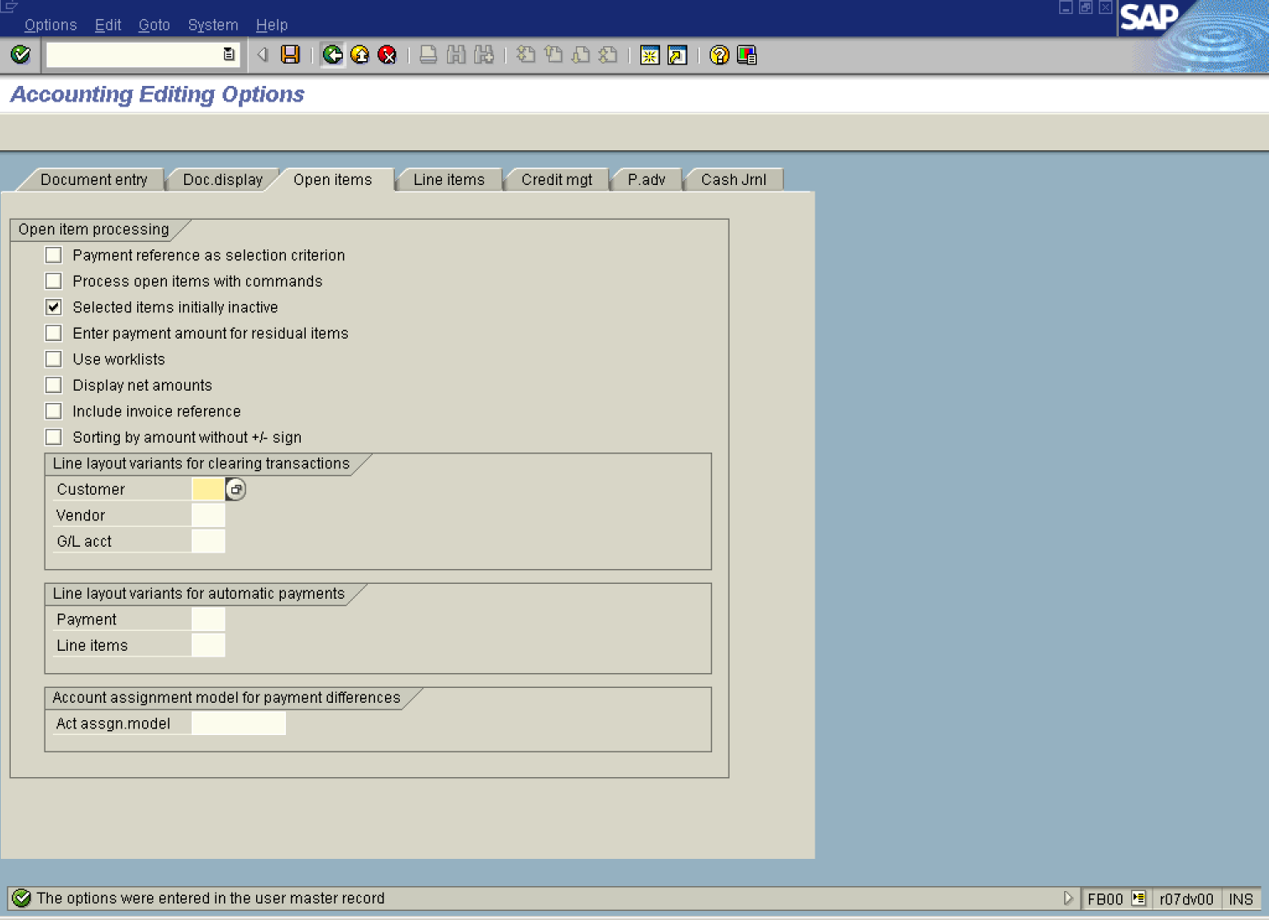

9. Click <checkbox> Selected items initially inactive .
10. Click Save Button.. The settings are now stored in user’s data.
11. Click Back Button . From now on, when you want to clear an account (Vendor, or GL account), all the items will be initially inactive. You need to click on the selected items to activate them for clearing.

